Year 10 History Assignment
Immigration Interview Assignment
Part 1:
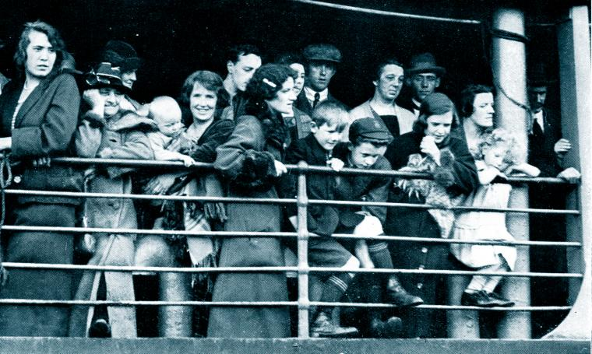
You will need to conduct an interview with someone that has migrated to Australia. This person can be a fellow classmate, parent, grandparent or friend.
You will need to prepare between 8-10 questions to ask your interviewee that will help you answer the question in part two
You will need to draft your questions and ensure that your teacher has checked through your questions. Ensure that your questions are open ended.

Part 2:
Choose one of the following questions, writing an individual response that uses evidence from your interview, textbook, and Weebly backing up your viewpoint. This is to be written as an extended response from your perspective and is to be between 500 – 600 words. Ensure that you reference your work.

- Discuss how Australia’s policy of Immigration has changed since 1945
- Immigration is easier now than it was 40 years ago.

You will need to hand up the following:
- Your interview Questions and Transcripts of the interview.
- Your individual response to one of Part 2 questions.

You will be marked on your ability to:
- Identify and select different kinds of questions about the past to inform historical inquiry.
- Process and synthesise information from a range of sources for use as evidence in a historical argument.
- Evaluate the reliability and usefulness of primary and secondary sources.
- Identify and analyse the perspectives of people from the past.

